System User Creation

<http://www.aemcq5tutorials.com/tutorials/create-system-user-in-aem/#create%20system%20user>

**Why System User are Introduced:-**

Use of admin session and admin resource resolver through ResourceresolverFactory is now deprecated, that’s why from AEM 6.1 Adobe forces developers to create system users and map them to Service User Mapper in Felix Console.

* Prevent excessive use of administrative JCR Sessions and ResourceResolvers.
* Allow services access to ResourceResolvers and JCR Sessions without requiring to hard-code or configure passwords.
* Allow services to use service users and/or system user which are specially configured for service level access.

#### ****Create System User in AEM:-****

1. Go to CRX Explorer (<http://localhost:4504/crx/explorer/index.jsp>)

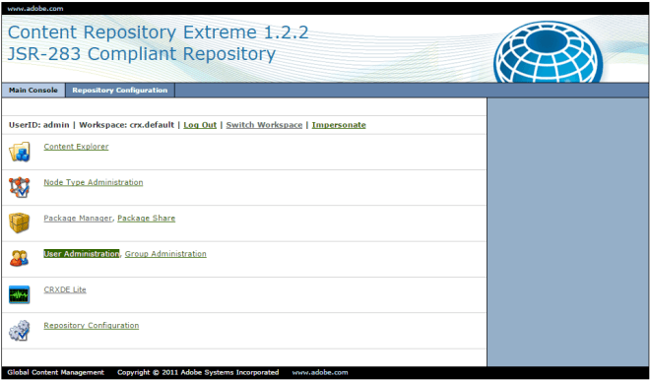

1. Click on User Administration.
2. Click on Create system User from Top Bar.
   * **UserId**- testSystemUser (User Id of system user you want to assign)
   * **Intermediate Path** – /home/users/system

**Note:-** *Path where you want to store system user. If no path is provided it will store user at some arbitrary node. This field is optional, but it is always advisable to provide path so that it will be easy to track user.*

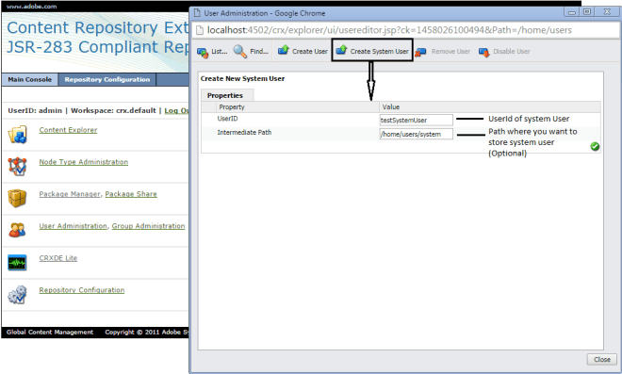

1. Click on **Green check box**.
2. Your system user is successfully created.

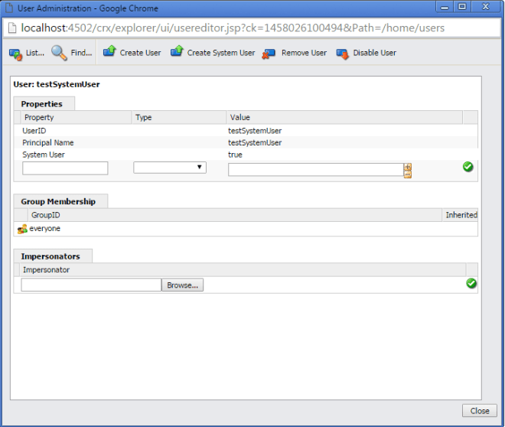

1. You can also view system user details from CRX DE at this path **/home/user/system.**

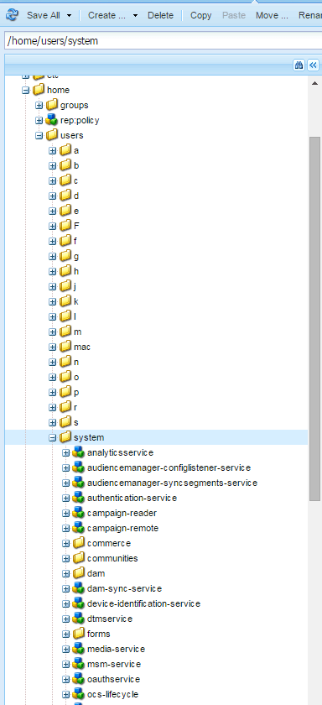

#### ****How to package system user using ACS commons acl packager:-****

In AEM, if we have to export users or groups from one environment to another we use packages. To transfer permissions along with user we use ACS commons acl packager.

As a pre-requisite let’s first add permission to our testSystemUser. Let’s consider we want this system user for content editing usage.

* Navigate to [User Admin Console.](localhost:4502/useradmin)
* Search for your user (testSystemUser).
* Select your user and go to Permissions Tab.
* Provide full access to ***/content*** folder. By selecting all check box against content row. You can ignore replicate checkbox as we don’t want this user for replication.
* Click on ***save***.

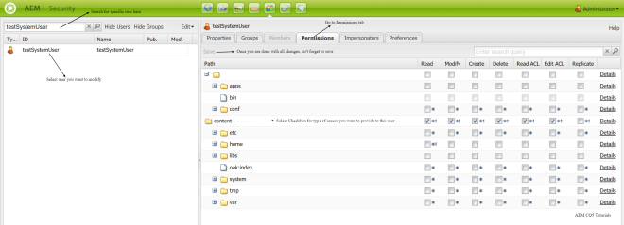

**Follow below steps to create ACS Commons ACL Packager:-**

* Log in to AEM Author.
* Navigate to the [Classic UI Tools Console](http://localhost:4502/miscadmin) (In case of Touch UI, You can navigate to ***Tools–>Operations –> Configuration***)
* Under the acs-commons folder, create a folder named ***packagers.*** (Name should be packagers, Title you can keep according to your choice, If you keep any other folder name apart from packagers then no template will be displayed).  
  ***NOTE:*** As of acs commons version 1.6.0, this folder is created automatically

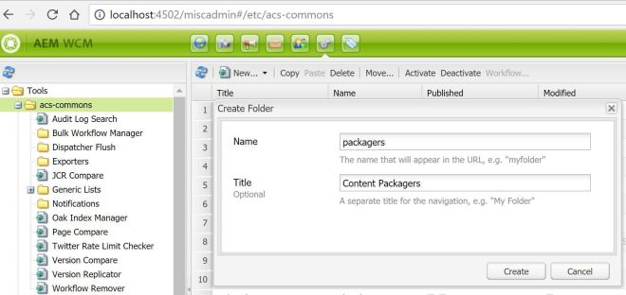

* Under the packagers folder, create a **new Page**of Template type “**ACL Packager**”

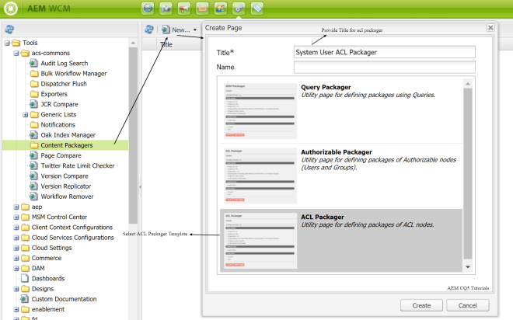

* Double click on newly created page.
* Click Edit.
* Enter values in dialog to configure the package rules and configuration.
  + **Add Principal Names: -** Add names of user that you want to export.
  + **Include Patterns:-** Add path from which you want to add ***rep:Policy or permissions***

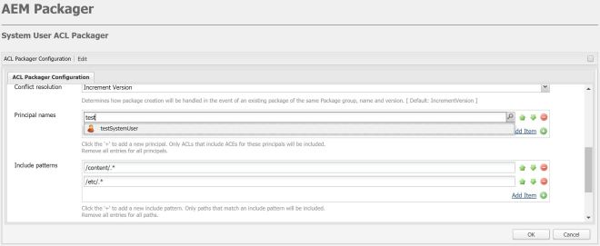

* Click OK, It will display a brief overview of your ACL Package.

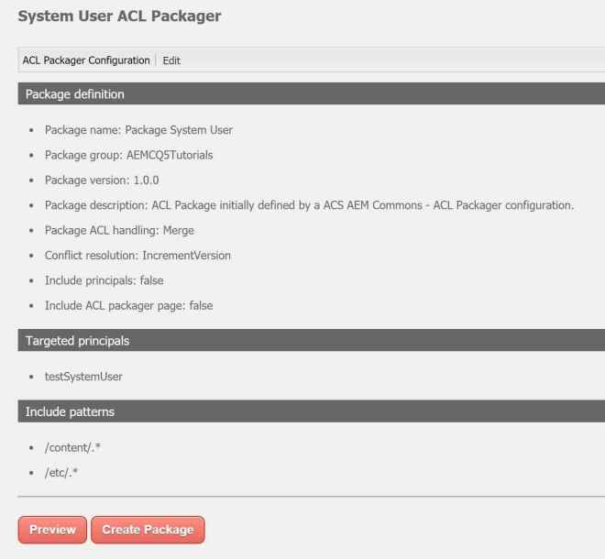

* Click on Preview button output a list of the access control entries which will be packaged.

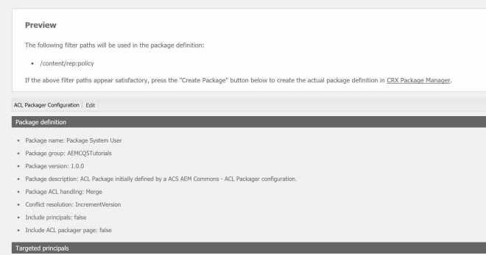

* Click on Create Package. That’s it you are done. You have successfully created acl packager package for system user at ***/etc/packages/AEMCQ5Tutorials/Package System User-1.0.0.zip***. Navigate to [crx package manager](http://localhost:4502/crx/packmgr/index.jsp) build and download your package. You can now import it on any environment where ever you want.  
  ***Note: -*** Once you have create a package you cannot change, package configuration. For changing package configuration you need to create a new acl package.

[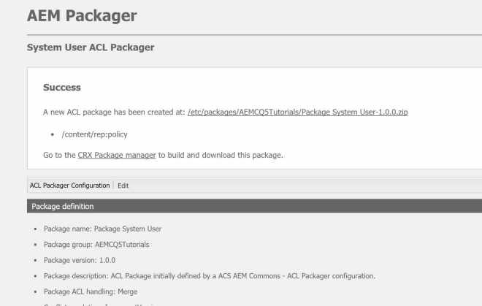](https://i0.wp.com/www.aemcq5tutorials.com/wp-content/uploads/2016/03/acl-packager-aem-created.jpg)